Lab Assignment 3

Chaudhary Hamdan

1905387

Date: 28-01-2022

Question: Change Regions of Userbases from 0 to 5 and check response times and plot graph

Screenshots:

Region 0:

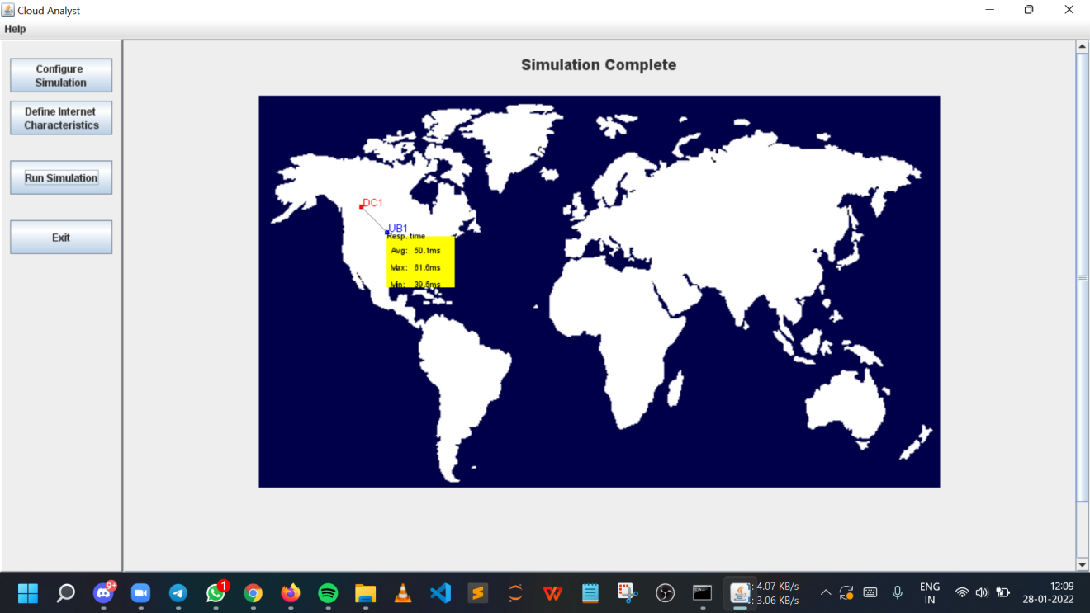

Region 1:

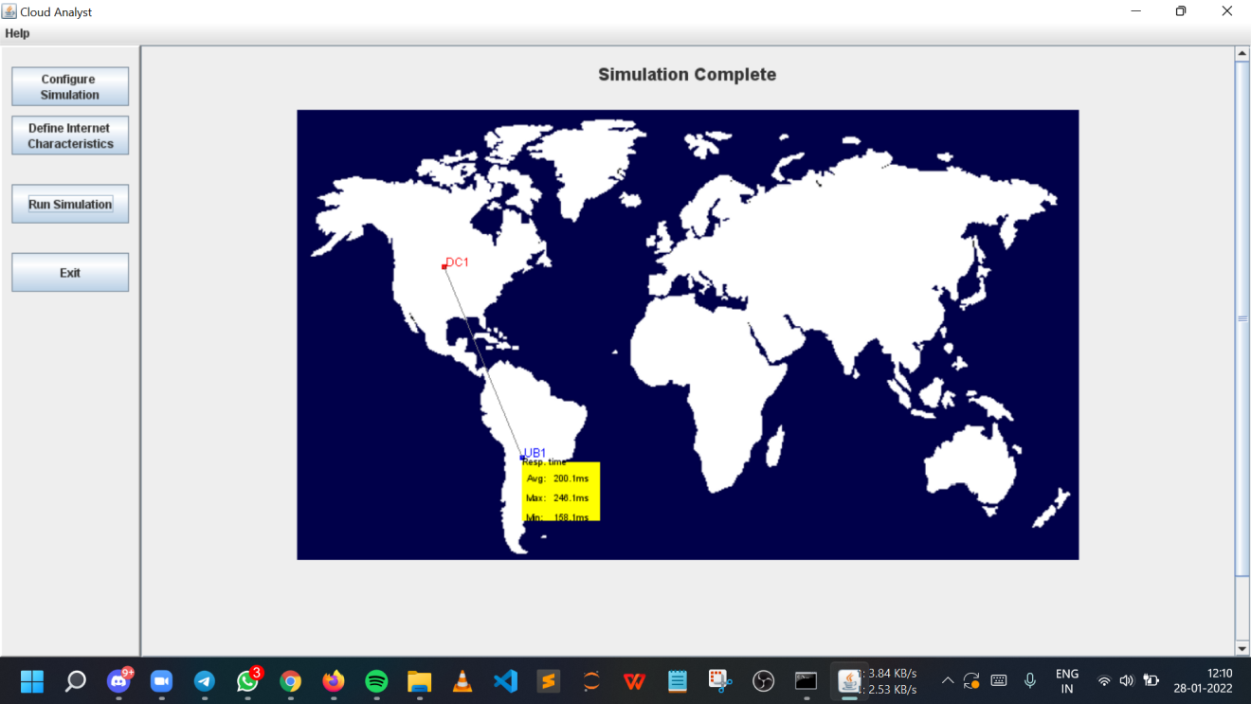

Region 2:

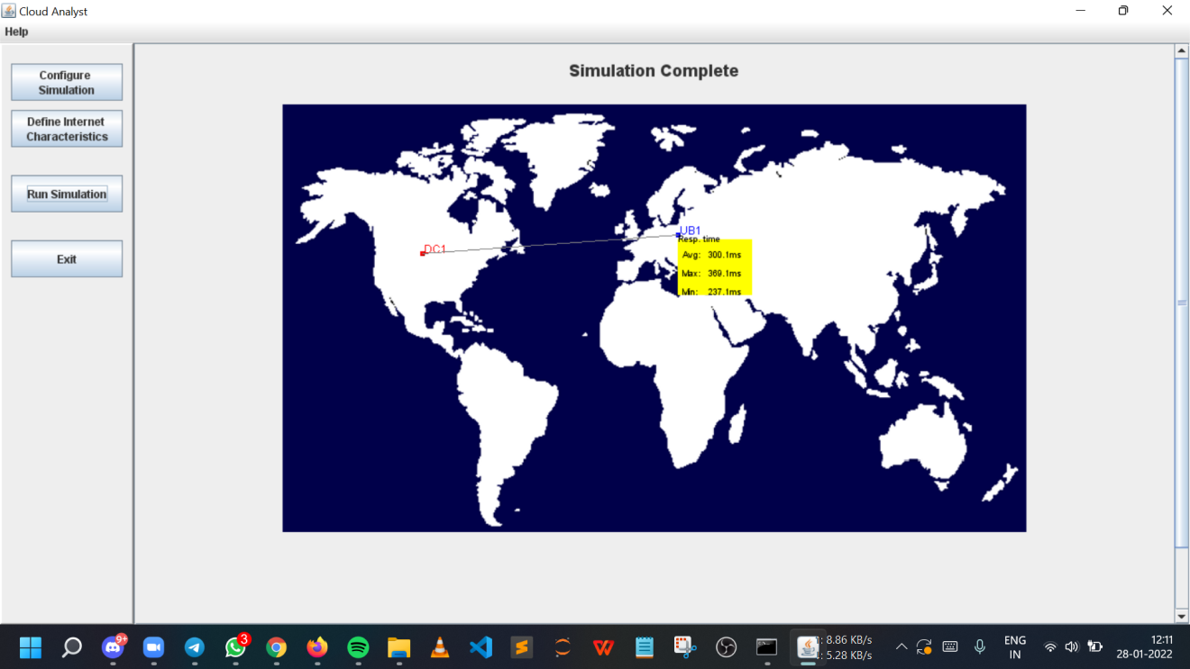

Region 3:

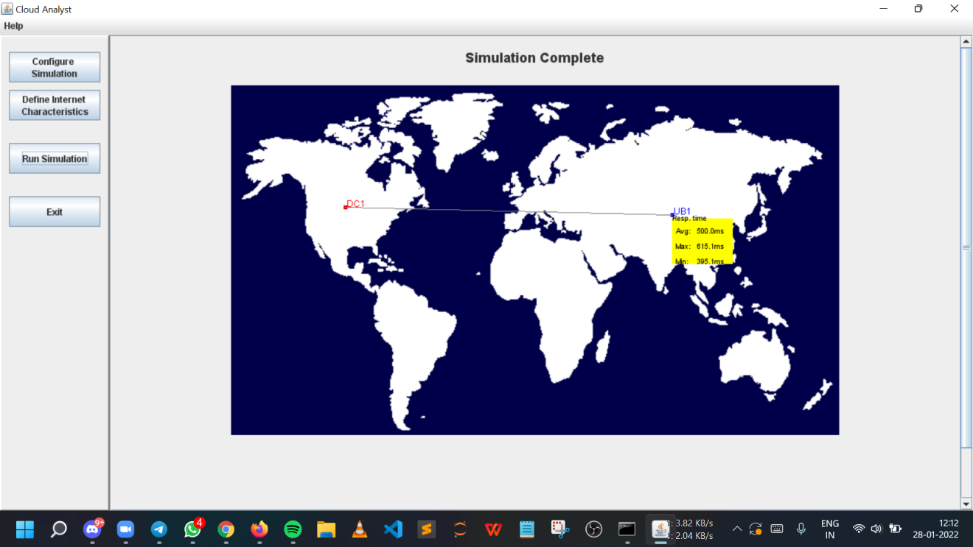

Region 4:

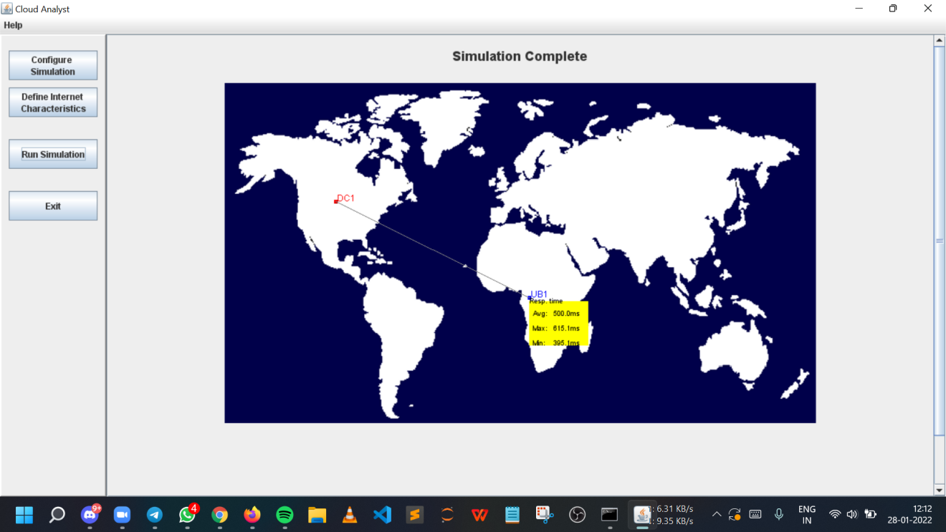

Region 5:

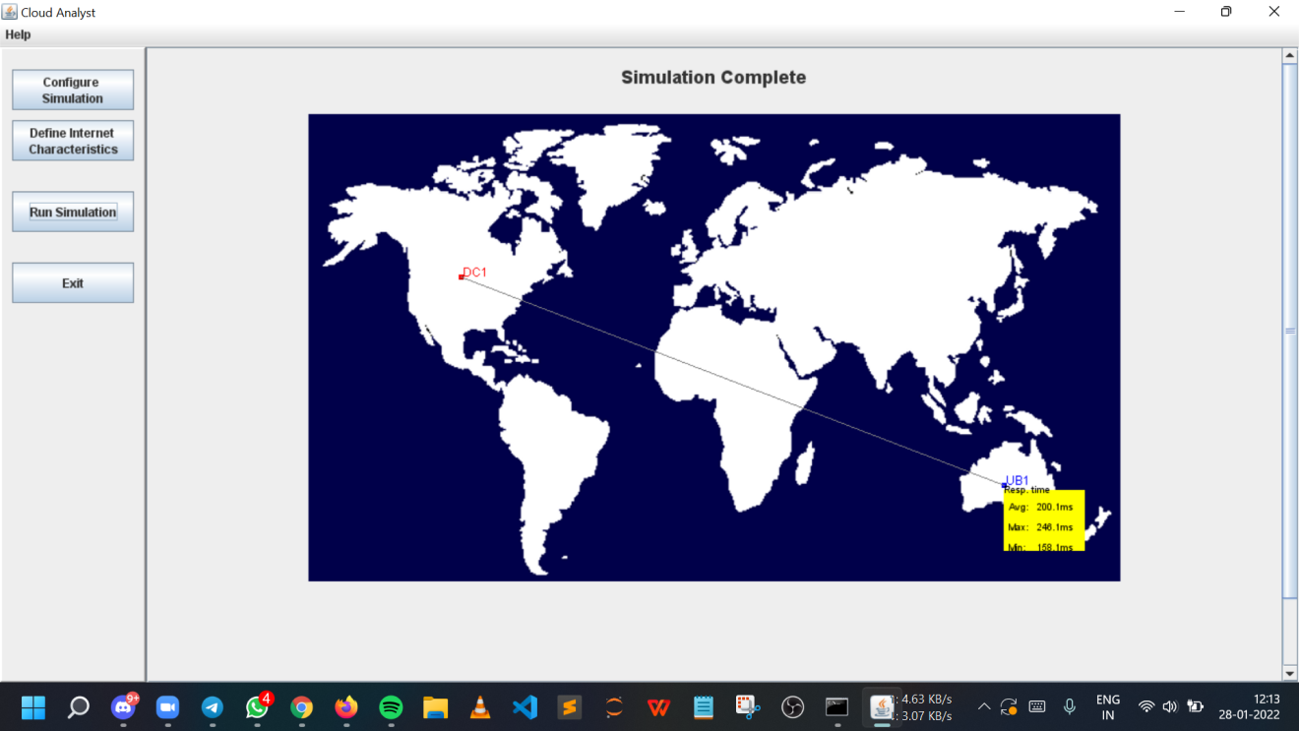

PDFs of all detailed results will be attached

in the following pages.